**DESKTOP**

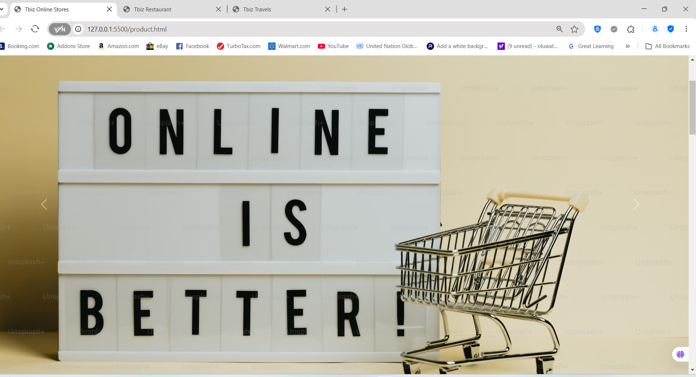

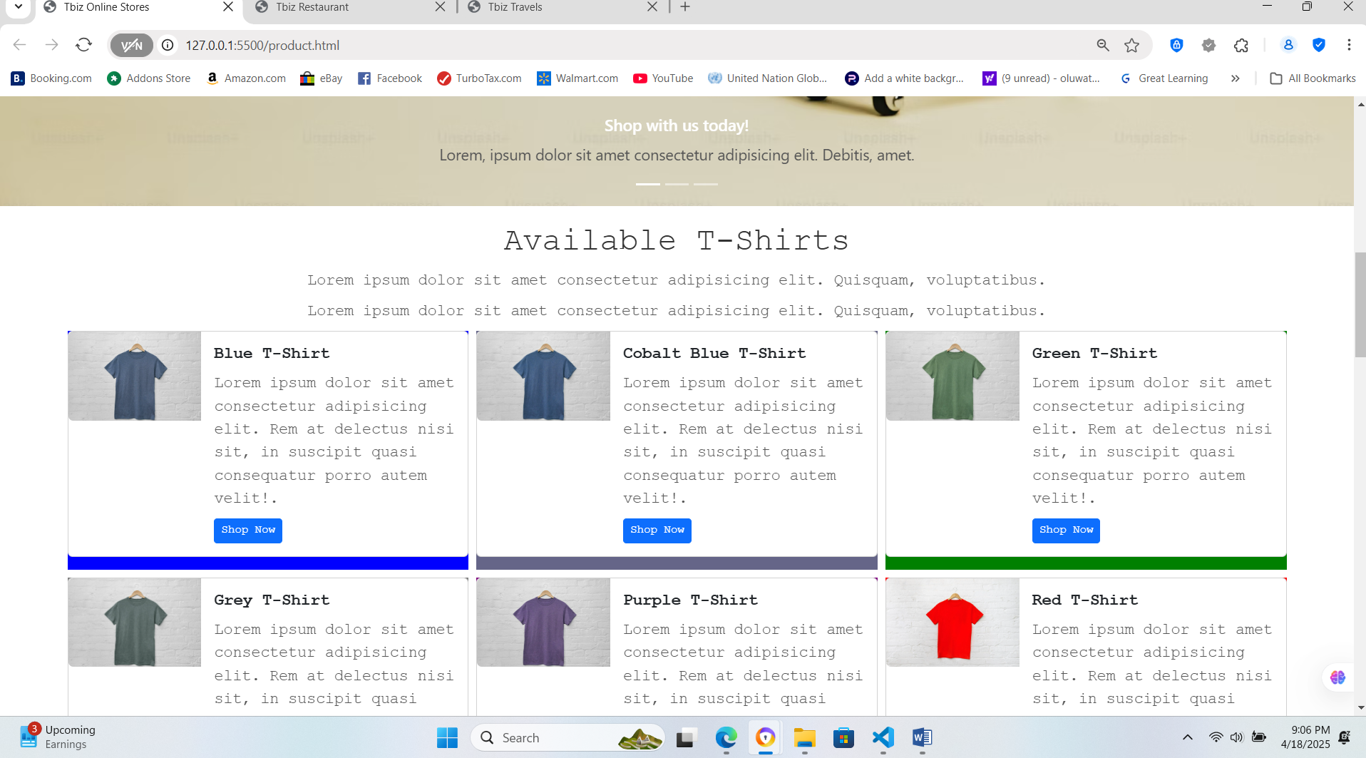

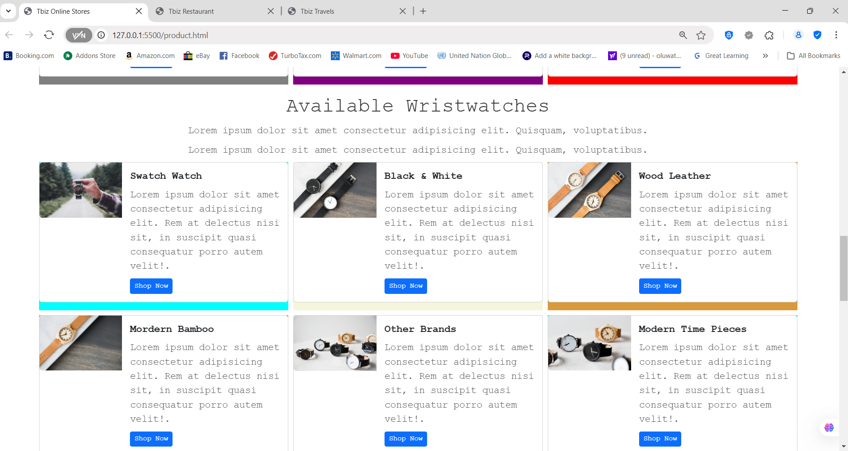

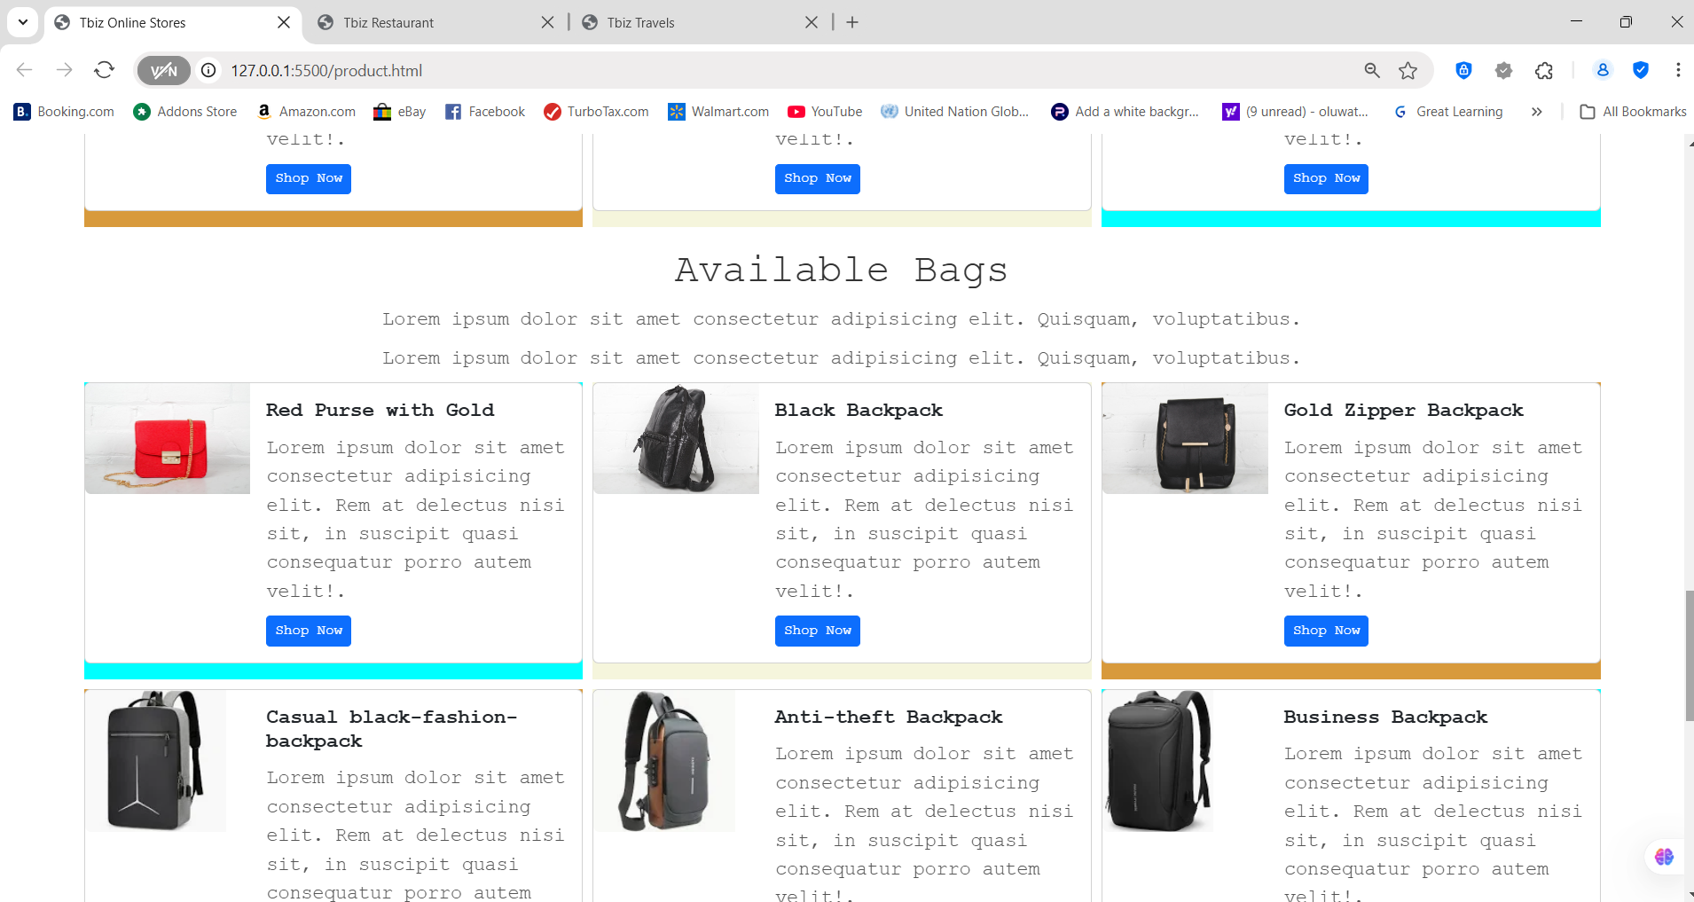

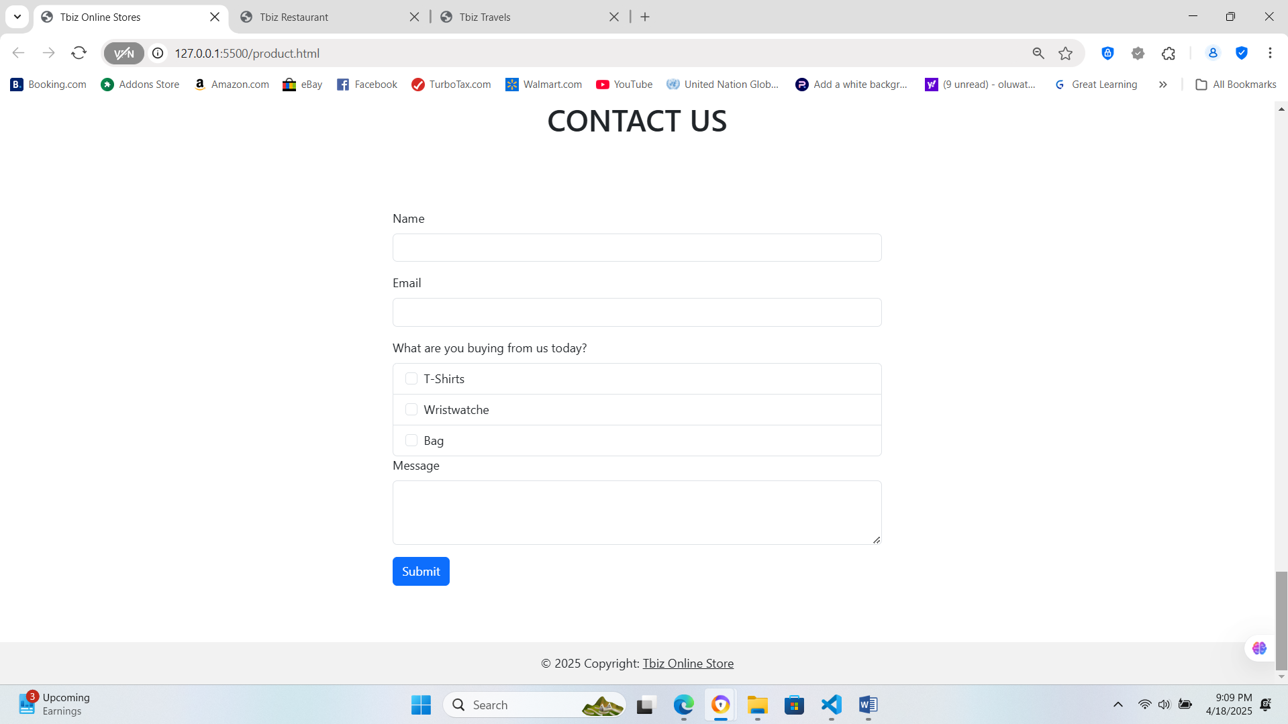

**TABLETS**

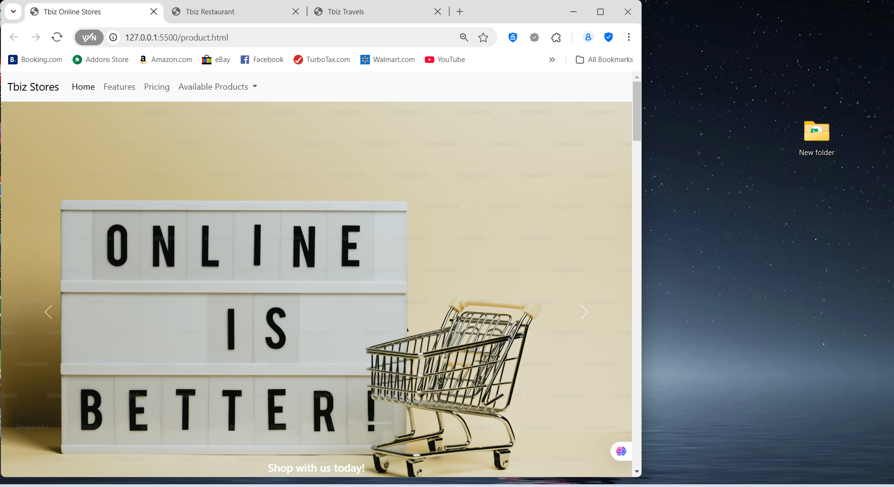

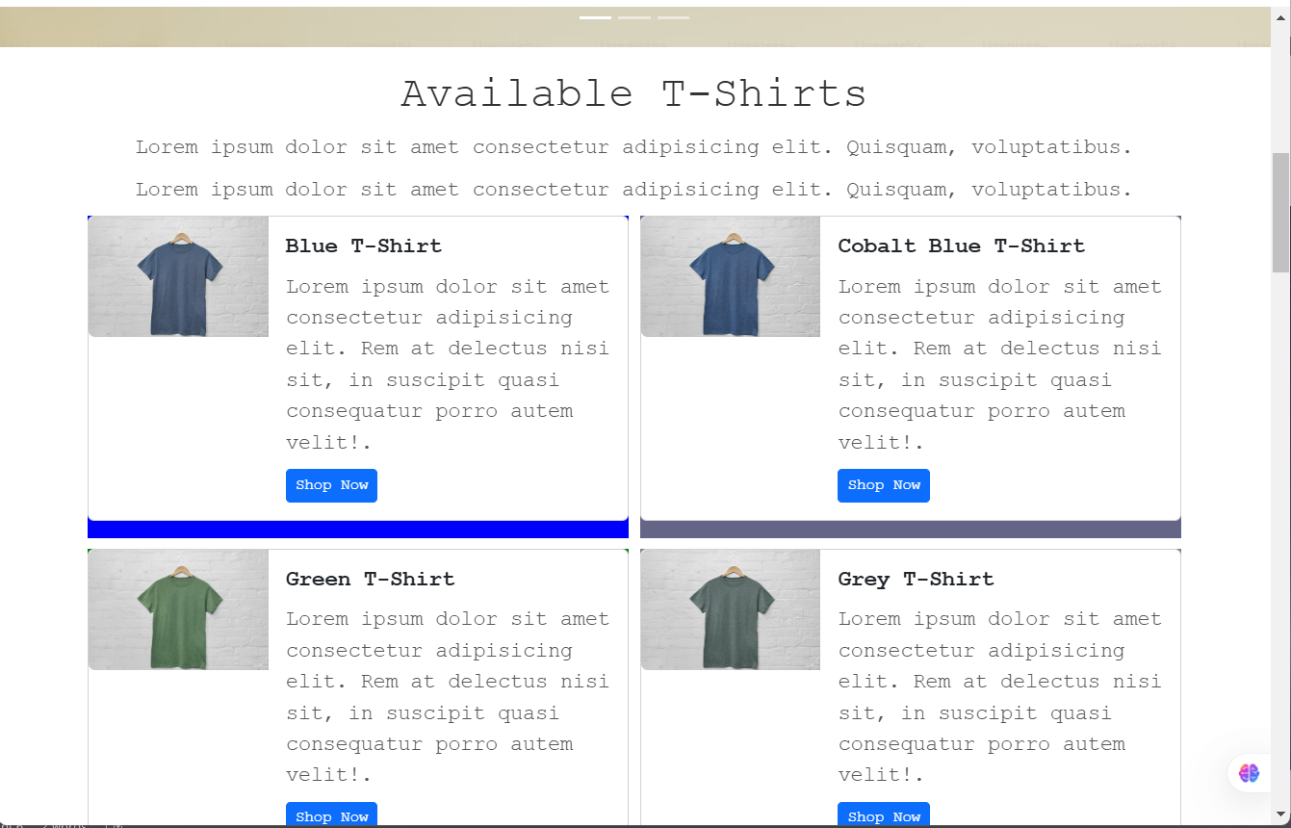

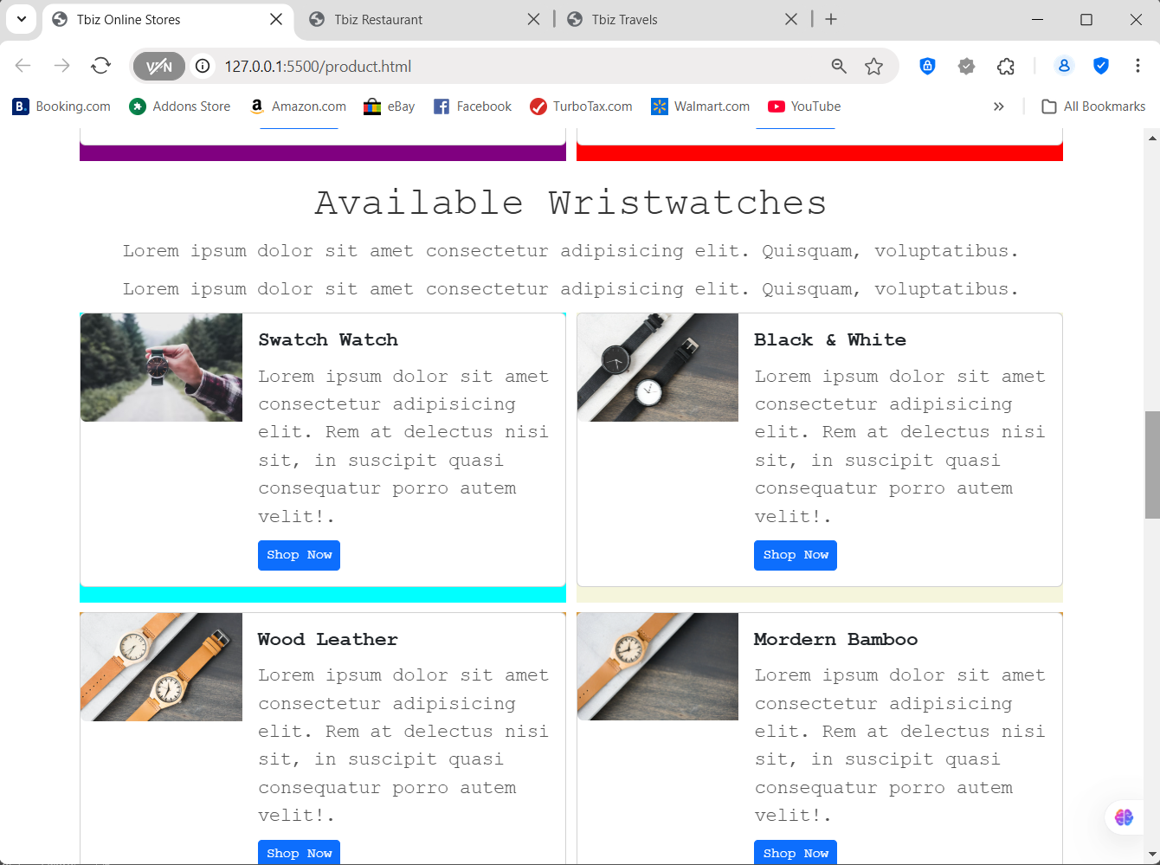

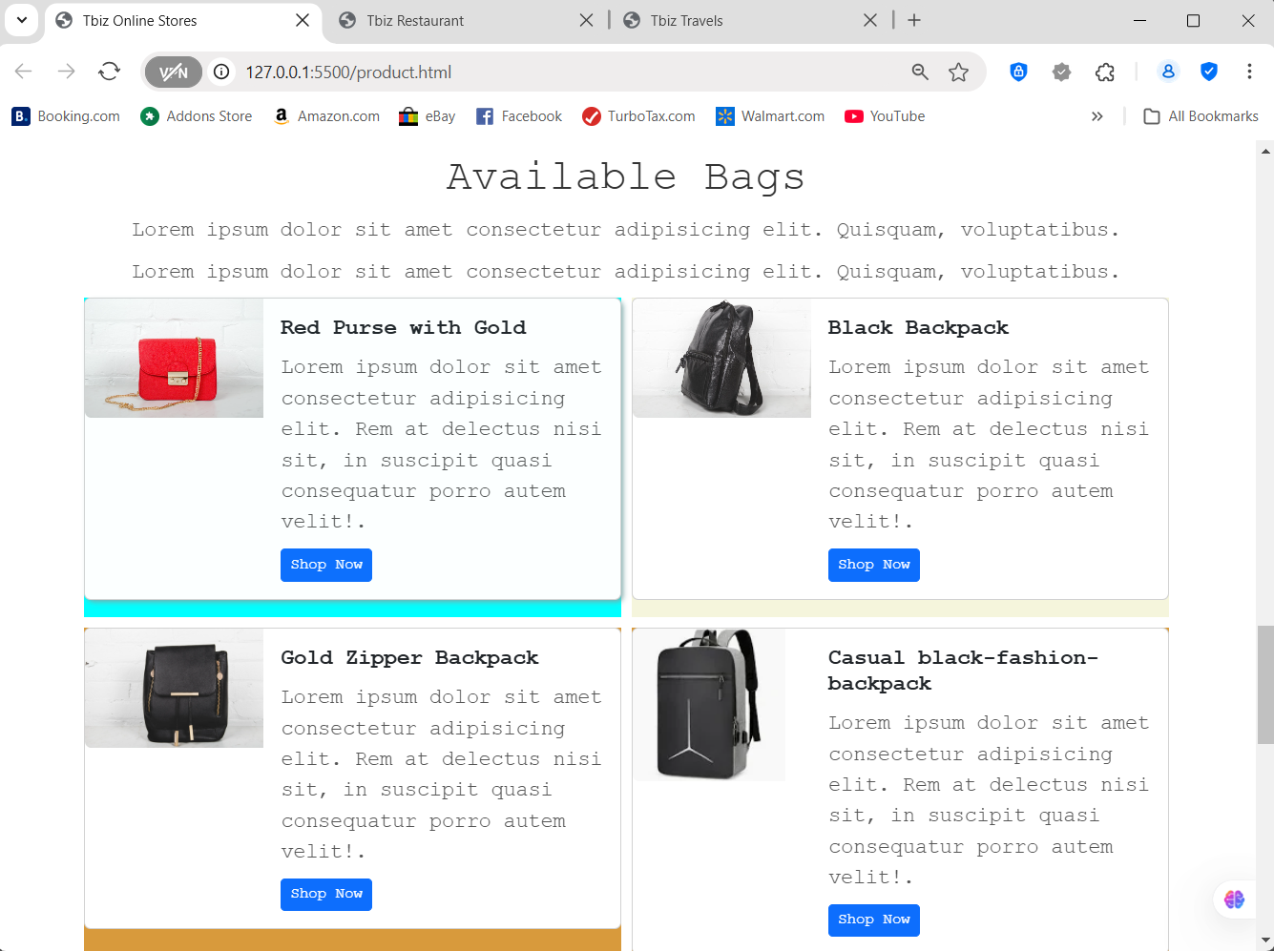

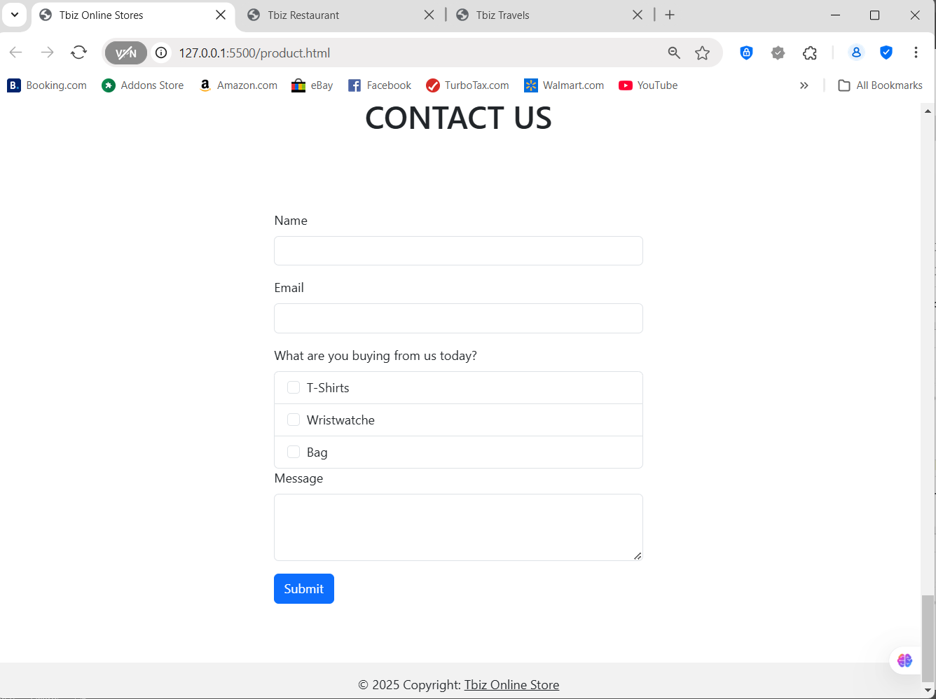

**PHONE SIZES**

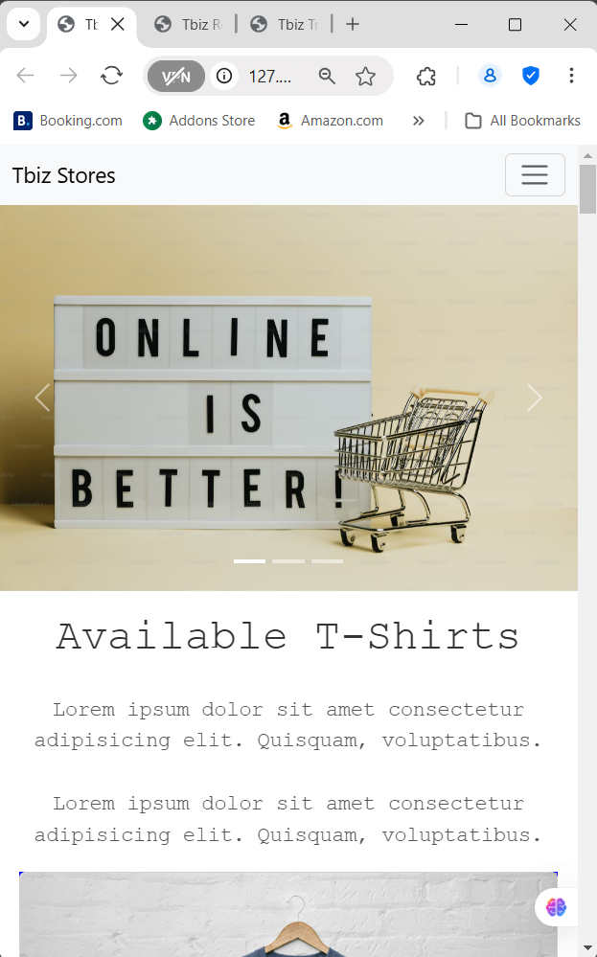

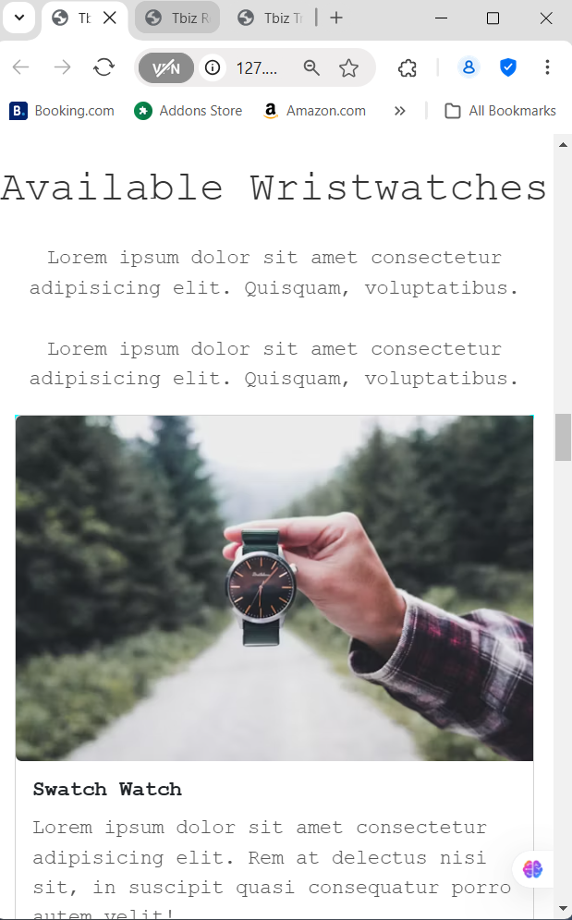

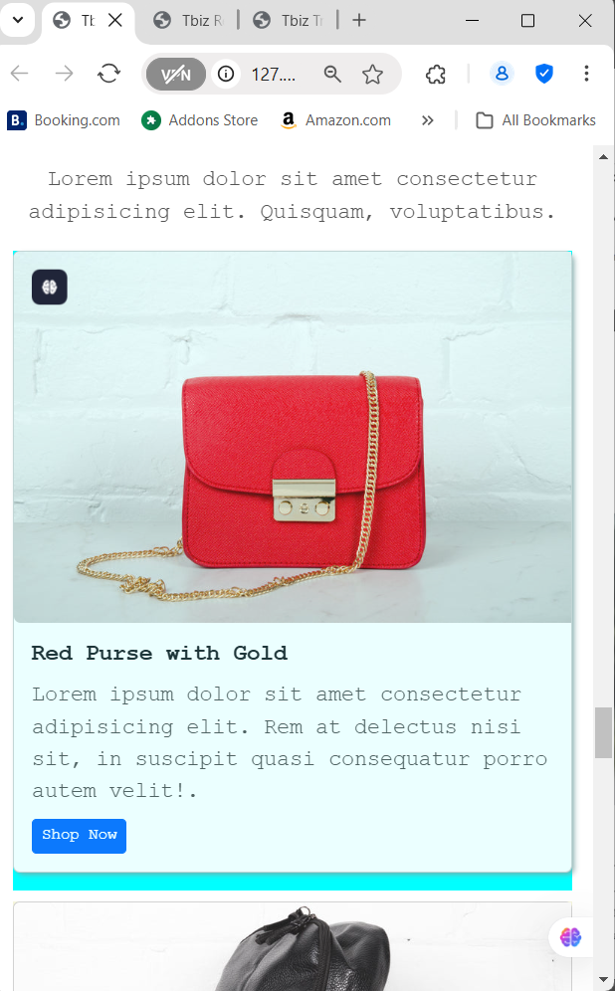

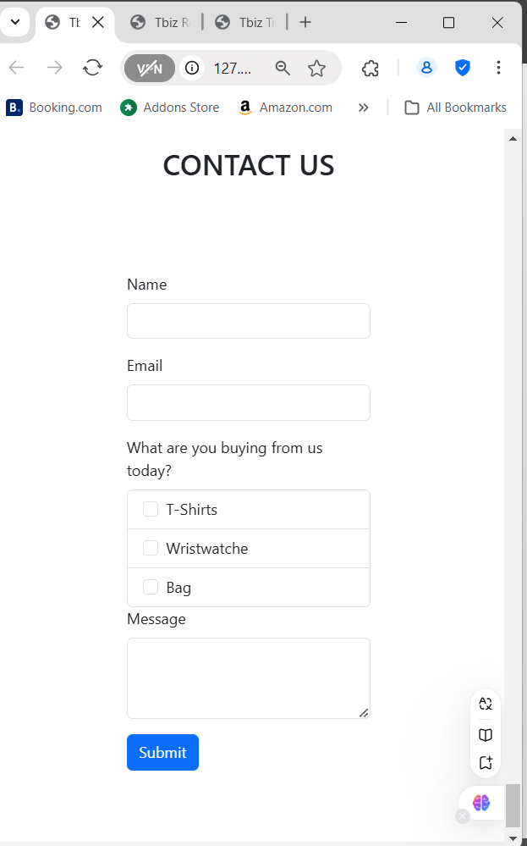

**DESIGN CHOICE USED.**

1. Divided the page into Header, Section, Main, Form and Footer
2. Use regular CSS to choose a base font for the website and a background colour
3. Created a visually appealing Carousel to spark user interest
4. Use Divs to divide the main content into a sublayout of 3 columns
5. Used CSS flex value to make the 3 columns flexible for different screen sizes
6. Then approach Bootstrap to pick the right cards to use.
7. Created a form to gather public requests and opinions
8. Created a footer to close page design